**Name:** Rameen **Roll No:** 2023-EE-03

EE-322L Analog and Digital Communication Marks Obtained: ________

**Lab Report**

**Experiment No. 6**

**Basic Operation of Phase Lock Loop (PLL)**

**Note:**

* **Don’t forget to include the two rubrics tables (available at the end in this document), otherwise reports will not be graded.**
* **Copy-pasted and plagiarized reports will get zero marks**

1. **Objective**
2. **Technical Background**
3. **Task-1**
   1. ***Description***

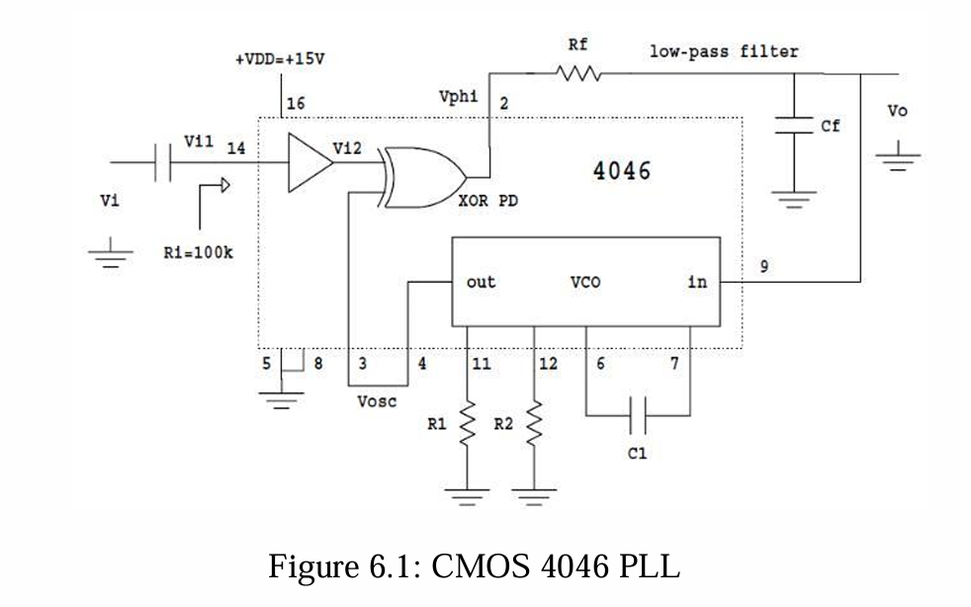

Implement the circuit given in Figure 6.1 on breadboard. Set the values of C1 to 0.03uF, while R1 and R2 to 18K.

Find out the **free-running frequency**, do not apply any reference or input signal to phase detector (pin 14). Observe the frequency of **the output signal at pin 4 of VCO**

* 1. ***Circuit, Design and Calculations***
  2. ***Results and Discussions (with all graphs and snaps)***

1. **Task-2**
   1. ***Description***
   2. ***Circuit, Design and Calculation***
   3. ***Results and Discussions (with all graphs, and snaps)***
2. **Task-3**
   1. ***Description***
   2. ***Circuit, Design and Calculations***
   3. ***Results and Discussions (with all graphs and snaps)***
3. **Task-4**
   1. ***Description***
   2. ***Circuit, Design and Calculations***

* 1. ***Results and Discussions (with all graphs and snaps***

1. **Task-5**
   1. ***Description***
   2. ***Results and Discussions (with all graphs, and snaps)***
2. **Conclusion**

**Rubrics for Experiment No.**

|  |  |  |  |  |
| --- | --- | --- | --- | --- |
| **Performance** | **Exceeds expectation (2)/(1)** | **Meets expectation (1)/(0.5)** | **Does not meet expectation**  **(0.5)/(0)** | **Marks** |
| **R1: Realization of Experiment’s Hardware on Breadboard.**  **Marks: 0-1** | The circuit is patched correctly, and safely, with neat  connections on the breadboard | The circuit is  patched neatly and correctly, but not in a workable form | Incapable to patch the circuit correctly and  neatly on breadboard |  |
| **R2: Knowledge of theoretical aspects**  **Marks: 0-2** | Has theoretical knowledge required for the experiment | Has partial theoretical knowledge about the experiment | Has no background knowledge about the experiment |  |
| **R3: Conducting Hardware**  **Experiment.**  **Marks: 0-1** | All the required tasks are correctly implemented | The required tasks are partially implemented | Unable to implement all the tasks even with guidance |  |
| **R4: Demonstrate proper results with justification.**  **Marks: 0-2** | Correct results are provided with required justification | Results are provided with  minor errors and/or with little  justification | Results are provided with major errors  and/or with no justification |  |

**Rubrics for Lab Manual No.**

|  |  |  |  |  |
| --- | --- | --- | --- | --- |
| **Performance** | **Exceeds expectation (0.5)/(0.25)** | **Meets expectation (-)/(-)** | **Does not meet expectation (0)/(0)** | **Marks** |
| **R1:** Timely submission  **Marks: 0-**  **0.25** | The submission is on  time | --- | Late submission |  |
| **R2:** Report completenes s  **Marks: 0-0.5** | All relevant calculations, specifications, code, graphs, and results are provided with proper  explanation. | All the relevant calculations,  specifications, code, graphs and results  are provided but with little  explanation and justification. | Most of the relevant graphs, results,  calculations, specifications, and code are missing, as well as their proper  explanation and  justification is also missing. |  |
| **R3:** Error-  free writeup  **Marks: 0-**  **0.25** | The submitted  assignment is without any plagiarism and formatting errors. | Some parts of the submitted  assignment contain formatting errors and plagiarized material. | The submitted assignment is mostly plagiarized and contain formatting errors. |  |